

Project Initialization and Planning Phase

Date | 26 June 2026
Team ID | xxxxxx
Project Name | Rising Waters: A Machine Learning Approach to Flood Prediction
Maximum Marks | 3 Marks

Define Problem Statements (Customer Problem Statement Template):
Create a problem statement to understand your customer's point of view. The Customer Problem Statement template helps you focus on what matters to create experiences people will love. A well-articulated customer problem statement allows you and your team to find the ideal solution for your customers' challenges. Throughout the process, you’ll also be able to empathize with your customers, which helps you better understand how they perceive your product or service.

Example: 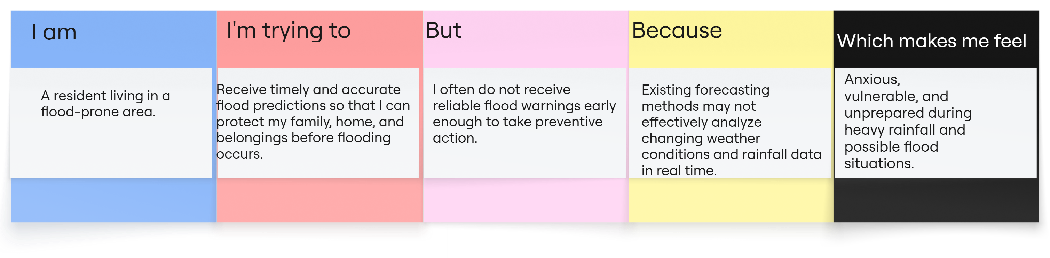
Problem Statement (PS) | I am (Customer) | I’m trying to | But | Because | Which makes me feel
PS-1 | A disaster management officer responsible for ensuring public safety during floods. | Identify flood-prone regions early and organize emergency response measures efficiently. | Analyzing large amounts of weather and rainfall data manually is time-consuming and prone to delays. | Flood prediction depends on multiple environmental factors that change continuously and require intelligent analysis. | Concerned about making timely decisions that can protect lives and reduce property damage.
PS-2 | A farmer whose crops and farmland are vulnerable to flooding. | Receive early flood predictions to protect my crops and livestock. | I do not have access to timely and accurate flood prediction information specific to my area. | Weather conditions change rapidly, making floods difficult to predict. | Worried about crop damage, financial losses, and the impact on my livelihood.

